Haines Borough Police Department
2023
UCR Statistical Report



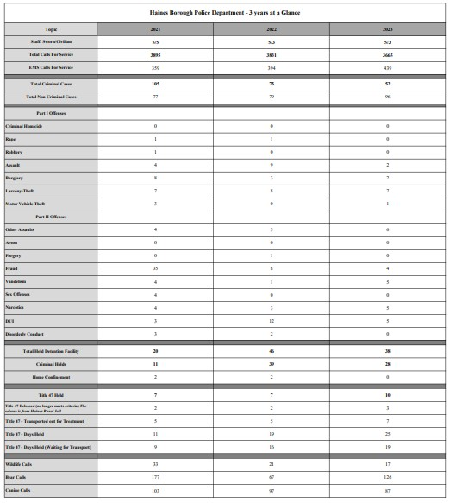
*Part II Offenses are only reported to Uniform Crime Reporting if an arrest was made.

Part I and II offenses from Uniform Crime Reporting 2020-2023.
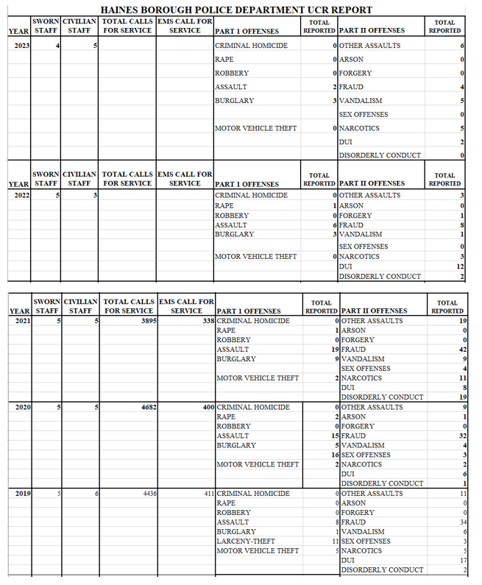
*Part II Offenses are only reported to Uniform Crime Reporting if an arrest was made.

In 2023 the Haines Borough Police Department investigated 167 cases.
Of these 167 cases 7.8% were non-criminal while the remaining 92.2% were criminal investigations.
The data displayed as follows:
Month report was received:
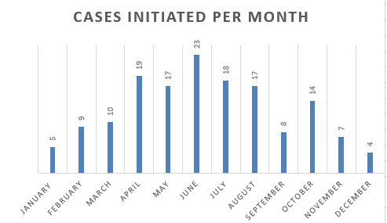
Time the incident was reported:
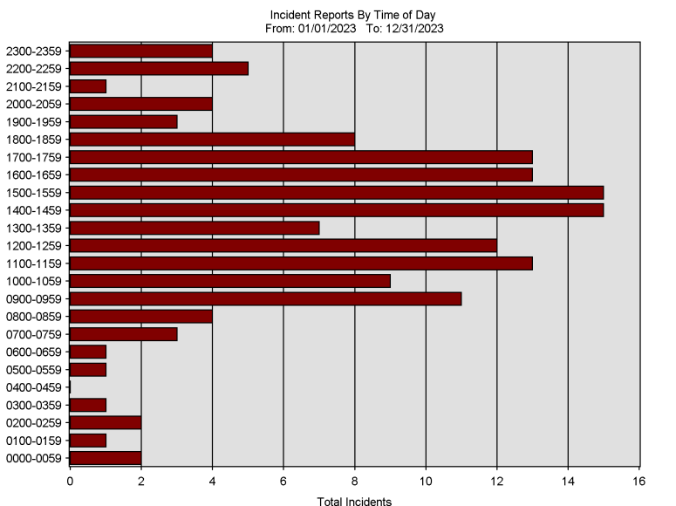
In 2023 the Haines Borough Police Department received 3665 Calls for Service. The data displayed as follows:
CFS by Time of Day:
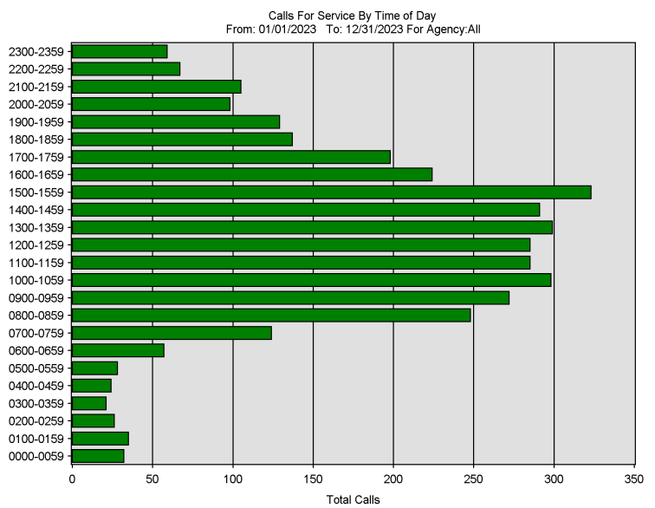
CFS by Day of Week:

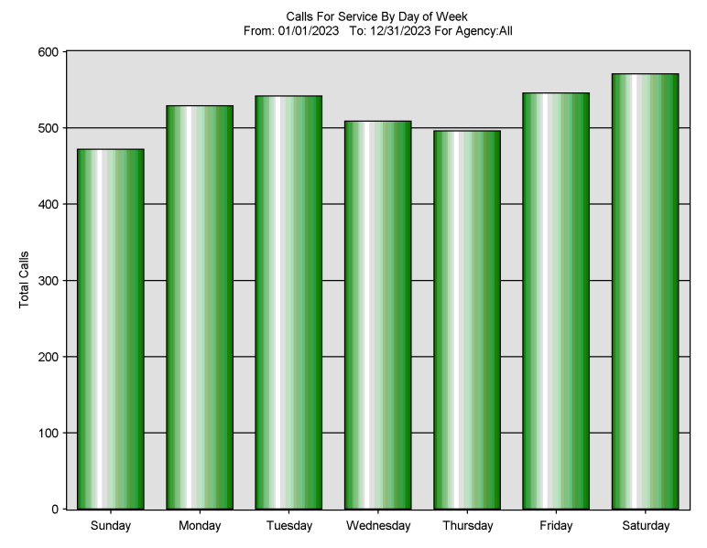

CFS by Month:
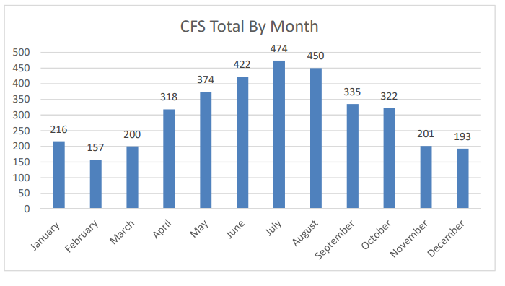
Assault Data:
HBPD received 12 reports of Assault. Of those reports, 12 suspects were identified and 3 were immediately taken into custody. Alcohol was a factor in 42% of the investigated assault cases and weapons were a factor in 17% of the investigations. The victim and suspect’s relationship were domestic in 34% of the assaults reported.
Burglary Data:
HBPD received 3 reports of burglary where the total value of reported property loss was $43,450.00; $0 of the losses were recovered. No suspects were arrested in any of the burglaries. The suspect(s) forced entry into 2 of the locations.
DUI Data:
HBPD investigated 5 DUI’s in 2023. 4 resulted in guilty convictions, none are pending sentencing.
Sexual Assault Data:
HBPD investigated 0 reported sexual assaults.

Prisoners in Custody:
In 2023 the Haines Rural Jail Facility booked 38 prisoners for a total of 90-man days served and supervised. 10 individuals were held under Title 47.
